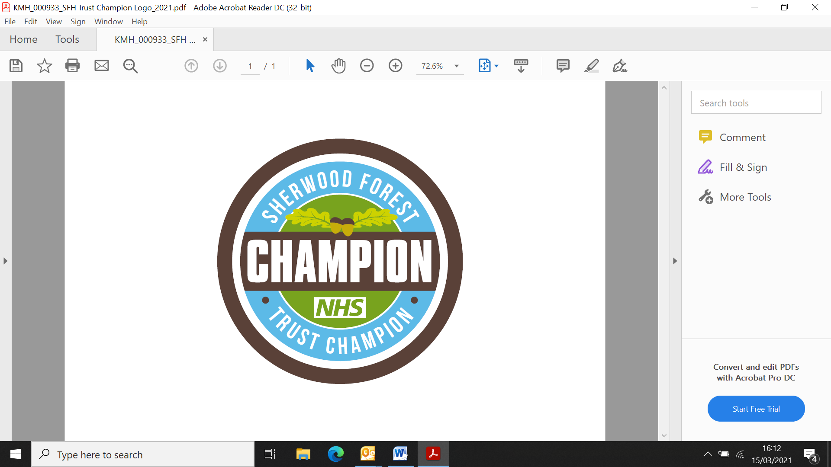

**1. Generic Champion role profile**

Title: Wellbeing Champion role

Time commitment: Minimum of an average of 4 hours per month

Responsible to: Trust People Wellbeing Lead

Date: January 2022

**3. Description of responsibilities**

1. Cascade wellbeing messages, including details about support and events; keeping colleagues up to date with trust-wide wellbeing initiatives and increase access to services
2. Support the Trust Wellbeing lead with promotion of events through communication with areas and also encourage team activities to be showcased during events (for example; videos, staff stories, attendance at events) to support a healthy workplace.
3. Support wellbeing initiatives and/or best practice recommendations to embed positive changes within the department/ward area
4. Utilise current wellbeing qualifications, skills and interests (e.g. fitness instructor, walk leader) to support colleagues across the trust
5. Contribute and attend ‘Wellbeing Champion’ supervisions, networks and forums to share best practice
6. Attend meetings with the Trust Wellbeing Lead, to help us shape the wellbeing agenda for the Trust
7. Capture feedback and ideas from teams/individuals to ensure our wellbeing work meets the needs of as many staff as possible
8. Inform and influence and contribute to the development and delivery of the Trust’s wellbeing strategy
9. Advocate, model and promote wellbeing practice
10. Listen, empathise and be approachable to colleagues
11. Work within own knowledge and skills limitations and to know when to contact specialist lead(s) for further support and advice for self, colleagues, patients, carers and families
12. Maintain an evidence log of champion activities (paper or electronic) to be used at appraisal discussions

**2. Purpose of the champion role:**

The Wellbeing Champion role will support the ambition to embed cultures of inclusion, compassion and wellbeing across the NHS. The NHS People Plan 2020-21 sets out a number of health and wellbeing ambitions that aim to enable NHS organisations to create cultures of wellbeing, in which their workforce feel supported and well at work. One of the ambitions in the NHS People Plan is a programme of work that encourages all NHS organisations to roll out a network of Health and Wellbeing Champions, in a way that works best for their organisation.

'The overriding purpose is to support the provision of the highest quality patient care through personal actions and continuous improvement.'

**Are you passionate about the health and wellbeing of your colleagues?**

**Are you a good listener and looking to help improve your colleagues Wellbeing?**

**Would you like training and support to improve the wellbeing of your colleagues?**

As a Wellbeing Champion you will:

* Support colleagues as needed, signpost to relevant internal and external resources and regularly check in.
* Embed Wellbeing within your designated area, team, speciality and or specialist interest area
* Encourage colleagues to take breaks and to look after themselves, for example: drinking plenty of fluids.
* Act as a liaison/link between the department/ward area and the Wellbeing lead

**4. Time commitment**

* This is a voluntary role for which your manager is requested to protect 4 hours per month of your working time to fulfil the duties outlined in the role description.
* Staff adopt the role voluntarily in addition to their substantive post therefore to have the capacity to engage with the role, take a responsibility, ownership and feel empowered to support other staff there needs to be regular protected time commitment
* The use of a champions evidence log can be reviewed by ward/department leaders to support the decision making process for any additional protected time requests that might be required

**5. Skills and knowledge**

* Passionate about the wellbeing speciality subject and willing to engage with colleagues
* Willingness to undertake subject speciality training and recommended e-learning
* Good listening and communication skills
* Personal and people development skills including team working
* Willing to role model respect and compassion to all colleagues.

**6. Training and support**

You will:

* Be supported by your line manager and the trusts Wellbeing lead
* Have the opportunity to meet and network with other champions
* Receive teaching/training on subjects relevant to the champion role
* Have access to key resources/ training materials provided by the specialist lead(s)
* Have shadowing opportunities and leadership development opportunities

**7. Benefits of being a Champion:**

As a Wellbeing Champion you will support colleagues to provide the very best patient experience and promote safe, effective patient centred care for all patients, carers and families who access services at Sherwood Forest Hospitals NHS Foundation Trust.

* You will have the opportunity to gain new experience, knowledge and skills within health and wellbeing (Suicide Prevention, Cultural Awareness, mediator training, for example) based on the needs of colleagues
* Gain greater confidence in Wellbeing conversations and signposting
* Be able to make improvements/effect change in relation to supporting NHS People Plan
* Being able to make a difference by educating staff and sharing best practice
* Support others to develop their knowledge and skills
* Network with like minded peers
* Opportunity as part of a career pathway

**7. Express an interest**

To express an interest in this role you please discuss the time commitment required with your line manager and complete the expression of interest application.