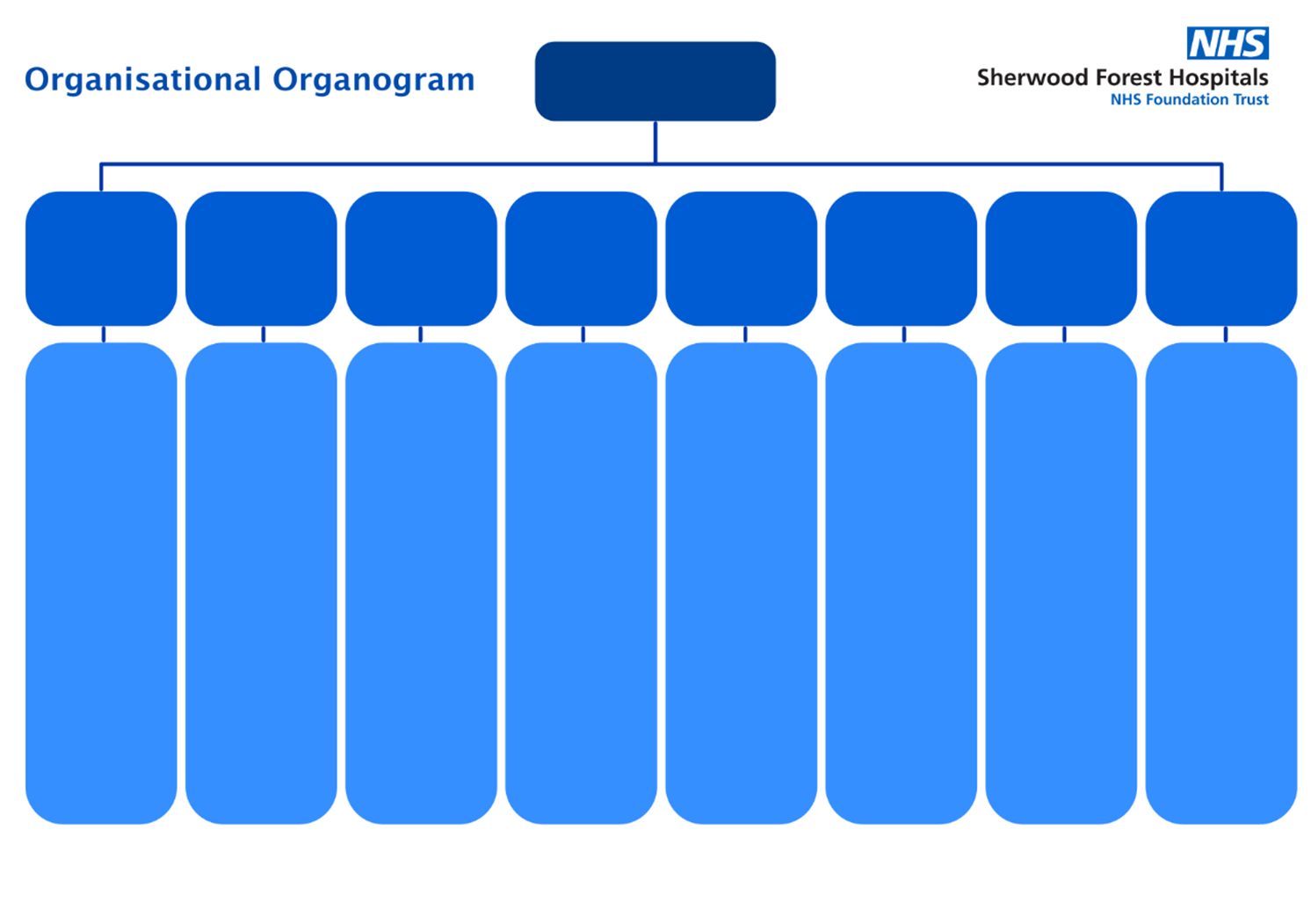

Chief Executive Officer

**Paul Robinson**



Interim Director of Strategy and Partnerships

**Claire Hinchley**

Head of Communications

**Richard Brown**

Mid-Notts ICP Programme Director

**Lorraine Palmer**

Associate Director Business Planning and Partnerships

**Kevin Gallacher**

Associate Director of Transformation

**Jim Millns**

Deputy Chief Finance Officer

**Jennifer Leah**

Head of Strategic Procurement

**Bob Truswell**

Associate Director of Estates & Facilities

Deputy COO

**Chris Dann**

5 Clinical Divisions

(See separate page)

Associate Director of Operational Performance

**Mark Bolton**

Associate Director of Operations- Planned Care

**Charlotte Ainger**

Associate Director of Operations- Emergency Pathway

**Janine Foxhall**

Emergency Planning & Business Continuity Officer

**Mark Stone**

Deputy Director of People

**Debbie Kearsley**

Associate Director of People

(Resourcing) **Donna Bowler**

Associate Director of People (Transformation)

**Richard Cotterill**

Associate Director of People

(Operations)

**Jacqueline Read**

Community Involvement Manager

**Jo Thornley**

Head of Data Security & Privacy

**Jacquie Widdowson**

Risk and Assurance Manager

**Neil Wilkinson**

Freedom to Speak Up Guardian

**Kerry Bosworth**

Director of AHP’s **Carl Miller**

Director of Nursing

**Shantell Miles**

5 Divisional Heads of Nursing / Midwifery

(See separate page)

Associate Director of Nursing

**Yvonne Simpson**

Lead Nurse Safeguarding

**Lisa Nixon**

Head of Governance

**Candice Smith**

Associate

Chief AHP

**Kate Wright**

Head of Patient Experience

**Grace Radford**

Chief Nursing Informatics Officer

**Claire Madon**

Director of

People

**Rob Simcox**

Deputy CEO/Medical Director

**Dr David Selwyn**

Chief Finance

Officer

**Richard Mills**

Director of Corporate Affairs

**Sally Brook Shanahan**

Chief Operating

Officer

**Rachel Eddie**

Deputy Medical Director

**Simon Roe**

5 Clinical Chairs

(See below)

Associate Medical Director

**Dr M Noor**

Director of NHIS

**Jaki Taylor**

Chief Informatics Officer

Clinical Lead for Digital Innovation and Transformation **Morgan Thanigasalam**

Trust Solicitor

**John Glendening**

Clinical Director of Patient Safety

**John Tansley**

Head of Regulation & Deputy Head of Clinical Governance **Patrick McCormack**

**Medical Examiner / Project Advisor**

**Nigel Marshall**

Chief Nurse

**Phil Bolton**



Chief Executive Officer

**Paul Robinson**



Director of

People

**Rob Simcox**

**WOMEN’S AND CHILDREN’S**

**Divisional Clinical Chair**

Srini Vindla*

**Divisional General Manager**

Matthew Warrilow

**Divisional Head of Nursing**

Paula Shore

**URGENT & EMERGENCY CARE**

**Divisional Clinical Chair**

Ben Owens*

**Divisional General Manager**

Steven Jenkins

**Divisional Head of Nursing**

Richard Clarkson

**CLINICAL SUPPORT, THERAPIES & OUTPATIENTS**

**Divisional Clinical Chair**

James Thomas*

**Divisional General**

**Manager**

Adam Littler

**Divisional Head of Nursing**

Lindsey Chapman

**SURGERY**

**Divisional Clinical Chair**

Bala Srinivasan*

**Divisional General Manager**

Jo Fort

**Divisional Head of Nursing**

Trevor Hammond

**MEDICINE**

**Divisional Clinical Chair**

Mark Roberts*

**Divisional General Manager**

Joanne Wright

**Divisional Head of Nursing**

Carly Rollinson

Key

* Divisional Clinical Chairs – Clinically Accountable to the Medical Director.

Chief Operating

Officer

**Rachel Eddie**

Interim Director of Strategy and Partnerships

**Claire Hinchley**

Deputy CEO/Medical Director

**Dr David Selwyn**

Chief Finance

Officer

**Richard Mills**

Director of Corporate Affairs

**Sally Brook Shanahan**

Chief Nurse

**Phil Bolton**

Deputy Chief Operating Officer for Elective Care

**Helen Hendley**

Chief Operating Officer

**Simon Barton**

Assistant Chief Operating Officer, Newark Hospital

**Anthony Rosevear**