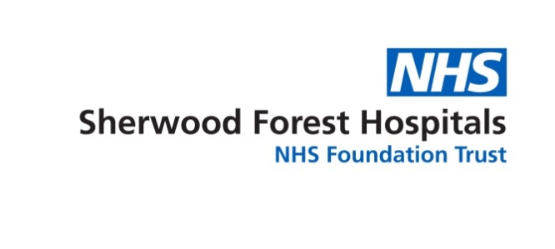

**Diversity and Inclusivity**

**Activity Report**

**2019 – 2020**

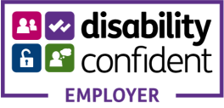 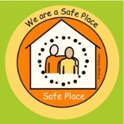 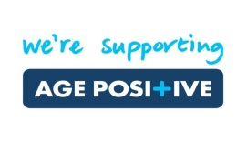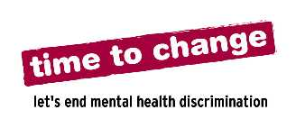

Contents

1.0 Background 4

2.0 Organisational 4

2.1.1 Equality, Diversity and Inclusivity Meeting 4

2.1.2 Staff Diversity Support 5

2.2 Trust Compliance with the Equality Act 2010 7

2.2.1 The Equality Duty 7

2.2.2 Specific Duties 7

2.2.3 Publication Duties 8

3.0 Gender Pay Gap Reporting 9

4.0 Equality Delivery System 2 (EDS2) 10

5.0 Workforce Race Equality Standard (WRES) 10

7.0 Equality Impact Assessments 11

8.0 Analysis of Data 11

8.1 Workforce Information 11

8.2 Membership 14

8.3 Our CARE Values 16

8.4 Staff Survey 2019 16

9 Human Resource Activities 17

9.1 Training and Development 17

**9.1.1** **Diversity and Inclusivity Training** 18

**9.1.2** **Mental Health Awareness Sessions for Managers – e-learning now** 18

**9.1.3** **LGBT Awareness and Hate Crime Training** 19

**9.1.5** **Orientation** 19

9.2 Human Resource Policies, Procedures and Practice 19

9.3 Workforce Recruitment 20

9.4 Mindful Employer 21

9.6 Time to Change 22

9.7 Age Positive 22

**10** **Supporting Vulnerable Adults (Including Learning Disabilities / Mental Health, Children and Young People)** 23

11 Chaplaincy Services 25

12 Diversity and Inclusivity Initiatives 28

12.1 Diversity Events 28

12.2 International Recruitment 31

12.3 Translation Services 32

13 Safe Places 32

14 Objectives for 2018/2021 32

**SHERWOOD FOREST HOSPITALS NHS FOUNDATION TRUST**

**DIVERSITY AND INCLUSIVITY ACTIVITY REPORT 2019 - 2020**

# Background

This report provides the Board of Directors with an update on the achievements, progress and developments in relation to the Equality, Diversity and Inclusivity agenda at Sherwood Forest Hospitals NHS Foundation Trust.

At the heart of everything we do is our dedication to giving the best possible care for patients. The Diversity and Inclusivity group has continued to take forward the Equality and Diversity agenda by ensuring equality legislation is embedded within the organisation whilst also working at operational levels within the Divisions and Corporate areas.

We are committed to providing an environment where all staff, service users and carers enjoy equality of opportunity. We oppose all forms of unlawful or unfair discrimination on the grounds of age, disability, gender reassignment, marriage and civil partnership, pregnancy and maternity, race, religion or belief, sex and sexual orientation, political affiliation, trade union membership and social and employment status.

We accept that such an environment requires individual differences and cultural diversity to be recognised and valued. Promoting equality, embracing diversity and ensuring full inclusion for people who use our services is central to the Vision and Values of the Trust and are fundamental to us in building strong communities and services. The Trust understands the importance of being compliant with the equality legislation and acknowledges the benefits and contribution that managing equality and diversity makes to the achievement of its business objectives in the areas of employment, service planning and service delivery.

The purpose of this report is to highlight the activities that have taken place during 2019/2020 and monitors the work being undertaken to achieve the Trust’s equality objectives.

# Organisational

## Equality, Diversity and Inclusivity Meeting

The Trust delivers the diversity and inclusivity agenda via a Equality, Diversity and Inclusivity (EDI) group, which meets bi-monthly. During 2019, the EDI agenda at the Trust was reviewed to acknowledge the differences between Workforce and Patient EDI and the bi-monthly group was separated in to a Workforce EDI Group (led by HR) and a Patient EDI Group (led clinically) in order to strengthen each strand. The Workforce EDI group was established in August 2019. Membership of the group has increased from the previous EDI group and membership is more representative of the workforce with divisional, staff side and medical representatives.

In order to continue to improve the delivery of EDI at the Trust, the group has annual work streams that are agreed by group members and progress reviewed at each meeting. For 2019/2020 the work streams are as follows:

* Embedding EDI across the Trust
* Development of our staff networks
* Recruitment and Retention of an inclusive workforce
* To ensure dignity at work for all - creating an inclusive workplace free from discrimination and stigma

The group provides regular reports to the Joint Staff Partnership Forum (JSPF) and provides an annual report to the Board of Directors which agrees the Trust’s priorities and actions to be delivered.

This report shows the initiatives and work completed in 2019/2020 to achieve these objectives.

## 2.1.2 Staff Diversity Support

We continue to have staff support networks for Black, Asian and Minority Ethnic (BAME) staff and Lesbian, Gay, Bisexual and Transgender (LGBT) staff. A BAME and LGBT employee champion also attend the Equality, Diversity and Inclusivity group on a bi-monthly basis to provide an arena for staff to raise their concerns or to raise suggestions of how to improve the working environment and patient care for BAME and LGBT groups.

Whilst the LGBT group continues to be a virtual support network, in 2018/2019 the BAME staff support network moved from a virtual network to a face to face network. Terms of reference were agreed and the network currently meets on a six weekly basis to support the Trust in meeting its statutory obligations regarding its duty under the Equality Act 2010.

Local and national events in relation to BAME and LGBT have been publicised throughout the Trust including Black History Month and LGBT History Month.

The Trust formally set up a new disability staff network which was communicated in the Trust communications bulletin on 1st August 2019 and in addition to calling for members the name of the network was proposed, WAND; ‘We’re Able aNd Disabled’. To date, the network has 9 staff members including 3 from Newark hospital.

The inaugural meeting of the staff network took place on 15th November 2019. During the meeting the Terms of Reference were agreed. In brief, the following was agreed;

* Purpose: to promote a safe and supportive working environment for disabled colleagues
* Aims:
  + To work to eliminate any workplace discrimination and promote equality
  + To influence and monitor policies from a disability perspective
  + To provide support to colleagues through events and signposting to support
  + To greater understand the experience of disabled people and promote disability equality in the workplace
  + To promote SFH as an inclusive employer and support the Trust in maintaining its status as a Disability Confident employer.

Non-Executive Director Tim Reddish supported the creation of the group and very kindly attended the Trusts first International Day of Persons with Disabilities event which took place on 3rd December 2019. Also in attendance were ‘Our Voice’ the community choir from Disability Nottinghamshire who closed the event with a performance of well-known songs and Christmas classics in the foyer of Kings Mill Hospital.

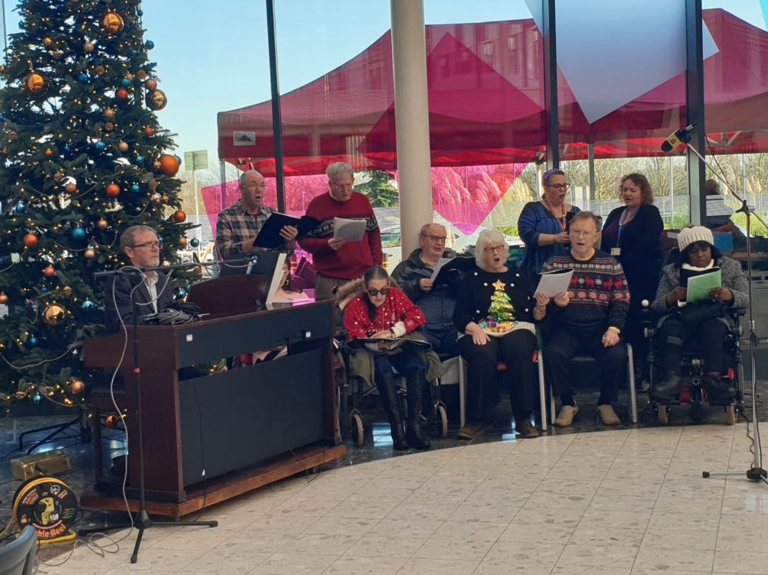

## Trust Compliance with the Equality Act 2010

### **The Equality Duty**

The Equality Act (2010) places an Equality Duty on public bodies which encourages the Trust to engage with the diverse communities affected by our activities to ensure that policies and services are appropriate and accessible to all and meet the different needs of the communities and people we serve.

The Equality Duty consists of a General Duty with three main aims. It requires the Trust to have due regard to the need to:

1. Eliminate unlawful discrimination, harassment and victimisation and other conduct prohibited by the Act.
2. Advance equality of opportunity between persons who share a relevant protected characteristic and persons who do not share it.
3. Foster good relations between persons who share a relevant protected characteristic and persons who do not share it.

Having ‘due regard’ means the Trust must take account of these three aims as part of our decision making processes; in how we act as an employer, how we develop, evaluate and review policy; how we design, deliver and evaluate services; and how we commission and buy services from others. The general duty is also underpinned by a number of specific duties which include the need for us to:

* Set specific, measurable equality objectives;
* Analyse the effect of our policies and practices on equality and consider how they further the equality aims;
* Publish sufficient information to demonstrate we have complied with the general equality duty on an annual basis.

### **Specific Duties**

The Equality Duty is supported by specific duties, set out in the regulations which came into force on 10th September 2011. The specific duties require public bodies to publish relevant, proportionate information demonstrating their compliance with the Equality Duty; and to set themselves specific measurable equality objectives. All information must be published in a way which makes it easy for people to access.

The information published must include;

* Information relating to employees who share protected characteristics (for public bodies with 150 or more employees); and
* Information relating to people who are affected by the public body’s policies and practices who share protected characteristics (for example, service users).
* However it is up to each public body to decide itself what information it publishes to show its compliance with the Equality Duty.

### **Publication Duties**

The information must be published on an annual basis. The Trust has published;

**Workforce Figures**

The information published on workforce figures identifies information in relation to the Trust’s workforce and protected characteristics as defined by the Equality Act 2010.

* Workforce Diversity and Inclusivity report March 2019
* NHS Staff Survey Summary 2019
* Workforce Race Equality Standards (WRES) July 2019
* Workforce Disability Equality Standard (WDES) July 2019
* Equality Dashboard 2018/2019
* Gender Pay Gap Report 2018-2019

**Patient Figures**

As part of the Equality Act 2010 information in relation to patients and protected characteristics must be collated and published. The patient figures published reports which are related to patients and particular protected characteristics are detailed below, however will be delayed in publishing due to COVID-19.

* Patient activity data on protected characteristics 2019-20
* Membership report within the Annual Report and Accounts 2019/2020.

**Organisational Information**

The Trust published its Equality Objectives Plan 2018-2021 along with the following documents which supports how the Trust is meeting the needs of the Equality Act 2010:

* Gender pay Gap Report 2019/2020
* Workforce Race Equality Standard (WRES) 2019
* Workforce Disability Equality Standard (WDES) 2019
* Disabled Access Report 2019
* Same Sex Accommodation Declaration

# Gender Pay Gap Reporting

In accordance with the Equality Act 2010 (Gender Pay Gap Information) Regulations 2017, employers with 250 or more employees are required to publish statutory calculations no later than 30th March each year.

The information aims to establish the pay gap between male and female employees as at 31 March the previous year. For example, 31 March 2019 pay information had to be published by 30 March 2020.

The Equality and Human Rights Commission defines the difference between equal pay and the gender pay gap as follows:

* Equal pay means that men and women in the same employment performing equal work must receive equal pay, as set out in the Equality Act 2010.
* The gender pay gap is a measure of the difference between men’s and women’s average earnings across an organisation or the labour market. It is expressed as a percentage of men’s earnings.

Salaries at the Trust are determined through a national NHS job evaluation scheme called Agenda for Change (AFC). Job evaluation evaluates the job and not the post holder. It makes no reference to gender or any other personal characteristics of existing or potential job holders. Therefore, the Trust is confident it is paying the same salary to roles of equal value.

The legislation requires an employer to publish six calculations:

* Average gender pay gap as a mean average
* Average gender pay gap as a median average
* Average bonus gender pay gap as a mean average
* Average bonus gender pay gap as a median average
* Proportion of males receiving a bonus payment and proportion of females receiving a bonus payment
* Proportion of males and females when divided into four groups ordered from lowest to highest pay.

A summary breakdown of our workforce by gender and pay banding as at March 2018, which was published in March 2020, can be found on the Trust’s internet site.

The Trust will undertake a number of actions which relate to these findings as follows:

* Gender analysis undertaken in relation to the Trusts leadership talent management work
* Use the information within this report to inform the Trust’s Diversity and Inclusivity work plan and objectives

# Equality Delivery System 2 (EDS2)

EDS2 is a mandatory framework to assist us with ensuring we treat our patients and staff fairly and equally. The Equality and Diversity Council (EDC) is currently leading on the development of EDS3 and are collating suggestions and seeking input ahead of its implementation. This is hoped to be launched as a pilot in 2020.

The Nottingham and Nottinghamshire ICS have requested to take part in the pilot of EDS3 as a system and a meeting with a representative from NHSE/I with Nottinghamshire Equality leads took place in late 2019.

Due to the imminent launch of EDS3, which was delayed due to the general election, we did not undertake our EDS2 grading exercise in December 2019. CQC have been made aware of the names of the Trust’s taking part in the EDS3 pilot in the New Year, therefore this did not affect our rating.

# Workforce Race Equality Standard (WRES)

The Workforce Race Equality Standard (WRES) is mandatory framework that we have to complete on an annual basis. The WRES standards are included in the NHS Standard Contract and all NHS organisations are required to demonstrate progress against nine indicators; four workforce data metrics, four staff survey findings regarding White and BME experiences, and one Board metric to address low levels of BME representation. The CQC inspect on the WRES implementation under the well-led domain. The Trust’s WRES data for 2018/2019 was published in July 2019 and a WRES action plan developed.

**6.0 Workforce Disability Equality Standard (WDES)**

The Workforce Disability Equality Standard (WDES) is a new mandatory standard introduced in April 2019. All NHS organisations are required to demonstrate progress against ten indicators; three workforce data metrics, six staff survey metrics and one Board metric. The Metrics have been developed to capture information relating to the experience of Disabled staff in the NHS. The Trust’s WDES report for 2018/19 data was published in June 2019 and a WDES action plan developed.

# Equality Impact Assessments

We have agreed that no policy, procedure or process can be approved until an Equality Impact Assessment (EqIA) has been carried out. An EqIA is the detailed and systematic analysis of the potential or actual effects of a policy, procedure or process, which is undertaken in order to establish whether the policy, procedure or process has a differential impact on different groups of people. The aim of the EqIA is to eliminate discrimination and produce positive outcomes for equality. EqIA audits are undertaken on a quarterly basis and reported back to the Diversity and Inclusivity group.

# Analysis of Data

## Workforce Information

The Trust is committed to treating all its service users and staff with dignity and respect. Embracing diversity supports the delivery of our strategic vision and helps to ensure that we are providing effective services that meet the needs of our community. SFH has an Equality Strategy, which is a public declaration of how we will demonstrably take forward our commitment to ensuring equality is embedded within all aspects of the organisation. Further details of our Equality Strategy can be found on the Diversity and Inclusivity page on the Trust’s website.

**Ethnicity**

In 2019/2020 the ethnicity composition continues to remain stable when compared with the previous year. The ethnicity profile of our staff is positive compared with the profile of the local community which is 4.5% BME. Staff from a Black, Asian or Minority Ethnic group has increased slightly compared to 2018/2019.

|  |  |  |  |  |
| --- | --- | --- | --- | --- |
|  | **2018/2019** | | **2019/2020** | |
| **Ethnic Origin** | **%** | **Headcount** | **%** | **Headcount** |
| Asian | 6.51% | 315 | 6.98% | 349 |
| Black | 1.72% | 83 | 1.94% | 97 |
| Chinese | 0.27% | 13 | 0.32% | 16 |
| Mixed | 1.47% | 71 | 1.82% | 91 |
| Not Stated/Undefined | 1.78% | 86 | 2.10% | 105 |
| White | 88.26% | 4,269 | 86.85% | 4,345 |
| **Grand Total** |  | **4,837** |  | **5003** |

**Disability**

The Trust collects data from all new employees regarding disability status and employees are encouraged to keep their staff record updated throughout their employment. The current data identified 22.37% of staff have not declared their disability status, a decrease compared to last year.

|  |  |  |  |  |
| --- | --- | --- | --- | --- |
|  | **2018/2019** | | **2019/2020** | |
| **Disabled** | **%** | **Headcount** | **%** | **Headcount** |
| No | 69.44% | 3359 | 71.82% | 3593 |
| Not Declared | 26.34% | 1274 | 22.37% | 1119 |
| Undefined | 1.03% | 50 | 1.12% | 56 |
| Yes | 3.18% | 154 | 4.70% | 235 |
| **Grand Total** |  | **4837** |  | **5003** |

**Staff Age Profile**

The overall age profile for the Trust’s workforce is dominated by the 41-50 and 51-60 age bands, something that the Trust is planning for in terms of potential retirements within coming years giving particular consideration to the Registered Nurse staff group where Nurses who have special class status can retire from 55 years of age. The facility for flexi-retirement continues to retain staffs' valuable knowledge, skills and experience within the Trust; allowing staff to retire and return to work. On the whole the age demographics continue to remain static, with a typical distribution across the age ranges. The Medical age profile is representative of the numbers of Doctors in training.

**Trust Age profile - % of staff - 31st March 2020**

|  |  |  |  |  |
| --- | --- | --- | --- | --- |
|  | **2018/2019** | | **2019/2020** | |
|  | **%** | **Headcount** | **%** | **Headcount** |
| Under 20 | 0.97% | 47 | 1.12% | 56 |
| 21-30 | 19.56% | 946 | 19.67% | 984 |
| 31-40 | 23.01% | 1113 | 23.85% | 1193 |
| 41-50 | 24.54% | 1187 | 23.67% | 1184 |
| 51-60 | 25.80% | 1248 | 25.26% | 1264 |
| 61-65 | 5.13% | 248 | 5.42% | 271 |
| 66 and over | 0.99% | 48 | 1.02% | 51 |
| **Grand Total** |  | **4,837** |  | **5003** |

**Medical Staff Age profile - % of staff - 31st March 2020**

|  |  |  |  |  |
| --- | --- | --- | --- | --- |
|  | **2018/2019** | | **2019/2020** | |
|  | **%** | **Headcount** | **%** | **Headcount** |
| Under 20 | 0.00% | 0 | 0.00% | 0 |
| 21-30 | 26.36% | 131 | 24.36% | 124 |
| 31-40 | 28.77% | 143 | 30.06% | 153 |
| 41-50 | 21.93% | 109 | 21.61% | 110 |
| 51-60 | 17.30% | 86 | 18.27% | 93 |
| 61-65 | 3.82% | 19 | 3.93% | 20 |
| 66 and over | 1.81% | 9 | 1.77% | 9 |
| **Grand Total** |  | **497** |  | **509** |

**Nursing Staff Age profile - % of staff - 31st March 2020**

|  |  |  |  |  |
| --- | --- | --- | --- | --- |
|  | **2018/2019** | | **2019/2020** | |
|  | **%** | **Headcount** | **%** | **Headcount** |
| Under 20 | 0.00% | 0 | 0.00% | 0 |
| 21-30 | 17.29% | 246 | 19.71% | 281 |
| 31-40 | 23.75% | 338 | 24.05% | 343 |
| 41-50 | 26.49% | 377 | 24.96% | 356 |
| 51-60 | 27.48% | 391 | 25.46% | 363 |
| 61-65 | 4.57% | 65 | 5.47% | 78 |
| 66 and over | 0.42% | 6 | 0.35% | 5 |
| **Grand Total** |  | **1,423** |  | **1426** |

**Gender**

In 2019/2020 the female workforce accounts for 81.35% of the total population of the workforce. This is a small increase when compared to the previous year’s figures. Male headcount increased slightly compared to the previous year; however the position continues to remain relatively static. Whilst the male demographic of the workforce is considerably lower than the local demographic, this is comparable with NHS national demographic.

|  |  |  |  |  |
| --- | --- | --- | --- | --- |
|  | **2018/2019** | | **2019/2020** | |
|  | **%** | **Headcount** | **%** | **Headcount** |
| Male | 18.90% | 914 | 18.65% | 933 |
| Female | 81.10% | 3,923 | 81.35% | 4070 |
| **Grand Total** |  | **4,837** |  | **5003** |

**Sexual Orientation**

In 2019/2020 the sexual orientation composition continues to remain stable when compared with the previous year. The current data identified 19.49% of staff have not declared their disability status, a decrease compared to last year.

|  |  |  |  |  |
| --- | --- | --- | --- | --- |
|  | **2018/2019** | | **2019/2020** | |
|  | **%** | **Headcount** | **%** | **Headcount** |
| Bisexual | 0.68% | 33 | 0.60% | 30 |
| Gay/Lesbian | 1.20% | 58 | 1.26% | 63 |
| Heterosexual | 76.58% | 3704 | 78.63% | 3934 |
| Do not wish to disclose | 21.54% | 1042 | 19.49% | 975 |
| Undefined | 0.00% | 0 | 0.02% | 1 |
| **Grand Total** |  | **4,837** |  | **5003** |

## 8.2 Membership

As a Foundation Trust we are proud of our membership totalling in excess of 21,000, which is around 5% of the local population. Excluding staff membership this number is closer to 16,000. The breakdown for this can be seen below:

**Public membership breakdown at 31st March 2020**

|  |  |  |  |
| --- | --- | --- | --- |
|  | **Number of members** | **Membership profile** | **Population profile** |
| **Age (years)** |  |  |  |
| 0-16 | 4 | 0.03% | 19.74% |
| 17-21 | 32 | 0.21% | 6.03% |
| 22+ | 14,215 | 92.34% | 74.22% |
| Not stated | 1,144 | 7.43% | 0% |
| **Ethnicity** |  |  |  |
| White | 13,737 | 89.23% | 89.29% |
| Mixed | 32 | 0.21% | 1.90% |
| Asian | 83 | 0.54% | 6.46% |
| Black | 31 | 0.20% | 1.79% |
| Other | 8 | 0.05% | 0% |
| Not stated | 1,504 | 9.77% | 0% |
| **Gender** |  |  |  |
| Male | 5,590 | 36.31% | 49.48% |
| Female | 9,604 | 62.38% | 50.52% |
| Not stated | 201 | 1.31% | 0% |

**Membership activity, events and communication**

As with the previous years, the Governors’ Membership and Engagement Committee has continued to focus on how best to engage with members. We have continued to host digital events via the monthly e-newsletter, Trust Matters. We have also continued to hold our monthly Meet Your Governor events across all three of our hospital sites, and have introduced these sessions out in the community at local leisure centres and colleges. These events enable governors to engage with members and the general public and to gain feedback on the services provided by the Trust.

**Forum for Public Involvement**

The Forum for Public Involvement continues to take place on the first Monday of every month. Discussions have taken place around various issues including PLACE audits, results of various staff and patient survey, review of upcoming patient information leaflets and at the most recent meeting the forum were updated on the Equality, Diversity and Inclusivity agenda.

## Our CARE Values

The values an organisation holds are central to how it plans, organises and delivers service. Our CARE values describe the ethos of the Trust and our approach to working with patients, the public, staff, and partner organisations. Our CARE values underpin the work of the Equality, Diversity and Inclusivity group, and are an effective framework to promote dignity, respect, embrace diversity and promote culture change.

## Staff Survey 2019

The Trust participates in the national NHS Staff Survey on an annual basis. The 2019 survey was undertaken from 1st October to 30th November.

In 2019 for the second year, the Trust elected to survey all staff and 3,161 staff responded giving a response rate of 66%, an increase of 4% on the previous year.

This year the staff survey findings are reported with the Key Findings with 11 ‘themes’. The themes are a specific line of questioning on areas such as; Equality, diversity & inclusion, Health & Wellbeing, Immediate managers and safe environment – bullying and harassment/violence. Like all other NHS Trusts in the country, we continued to operate against a backdrop of significant financial pressures and continued high demand on services. Positively, despite these pressures improvement has been sustained. Our results improved in 8 of the 11 themes, with no change in 2 and deterioration in 1 theme.

The overall indicator of staff engagement for the Trust was 7.2 (out of a maximum score of 10), which was well above average when compared to trusts of a similar type. This was a slight decrease to the previous year’s score of 7.3 however we have still remained above average for the past 4 years.

**Staff recommending the Trust as a place to work or receive treatment**

This is one of the significant measures articulated by the NHS Staff Survey results. Questions Q21a, Q21b, Q21c and Q21d feed into the Staff Engagement theme.

|  |  |  |  |  |  |
| --- | --- | --- | --- | --- | --- |
|  | **2015** | **2016** | **2017** | **2018** | **2019** |
| **Q21a “Care of patients/service users is my organisation’s top priority”** | 69.9% | 80.9% | 80.4% | 84.1% | 82% |
| **Q21b “My organisation acts on concerns raised by patients/service users”** | 64.6% | 76.6% | 76.3% | 81% | 77.9% |
| **Q21c ‘I would recommend my organisation as a place to work’** | 46.7% | 68% | 69.5% | 70.6% | 73.3% |
| **Q21d “If a friend or relative needed treatment, I would be happy with the standard of care provided by this organisation”** | 57.2% | 73.2% | 77.6% | 79.4% | 78.6% |

The 2019 Staff Survey results have been communicated to Divisions/Departments across the Trust. The Divisions and Departments were in the process of communicating the results to staff and developing plans however this was put on hold and has not taken place due to the COVID-19 pandemic. We are still awaiting national guidance on the Staff Survey.

# Human Resource Activities

## 9.1 Training and Development

The Training, Education and Development Department at Sherwood Forest Hospitals NHS Foundation Trust have a strong regional reputation for the quality of its education and training provision. The department is extremely proud of the role it plays in developing our current and future workforces to provide high quality and safe patient care.

|  |  |  |  |  |  |  |  |  |  |  |  |  |
| --- | --- | --- | --- | --- | --- | --- | --- | --- | --- | --- | --- | --- |
| **Sherwood Forest Hospitals NHS Foundation Trust** | | | | | | | | | |  | | |
| **Training Activities 2019/2020 Gender/Ethnicity Profile** | | | | | | | | | |  | | |
|  | |  | |  | |  |  | | |  | | |
| **Course Title** | | **Male** | |  | | **Female** |  | | | **Total Gender** | | |
|  | | **Number** | | **%** | | **Number** | **%** | | | **Number** | | |
| Customer Relations | | 105 | | 22 | | 362 | 78 | | | 467 | | |
| Health & Safety | | 795 | | 27 | | 2192 | 73 | | | 2987 | | |
| Induction | | 387 | | 16 | | 2007 | 84 | | | 2394 | | |
| Informatics | |  | |  | |  |  | | |  | | |
| Medical Equipment | | 1316 | | 10 | | 11567 | 90 | | | 12883 | | |
| Occupational Knowledge & Skills | | 2797 | | 13 | | 18803 | 87 | | | 21600 | | |
| Personal Development | | 216 | | 13 | | 1448 | 87 | | | 1664 | | |
| Resuscitation | | 701 | | 29 | | 1743 | 71 | | | 2444 | | |
| Risk Management | | 3271 | | 20 | | 13341 | 80 | | | 16612 | | |
|  | | | | | | | | | | | | |
| **Course Title** | **White** | |  | | **Other Ethnic Background** | | |  | **Not Stated** | |  | **Total Ethnicity** | |
|  | **Number** | | **%** | | **Number** | | | **%** | **Number** | | **%** | **Number** | |
| Customer Relations | 399 | | 85 | | 62 | | | 13 | 6 | | 2 | 467 | |
| Health & Safety | 2577 | | 86 | | 367 | | | 12 | 43 | | 2 | 2987 | |
| Induction | 1878 | | 78 | | 425 | | | 18 | 91 | | 4 | 2394 | |
| Informatics |  | |  | |  | | |  |  | |  |  | |
| Medical Equipment | 11016 | | 86 | | 1575 | | | 12 | 292 | | 2 | 12883 | |
| Occupational Knowledge & Skills | 18524 | | 86 | | 2695 | | | 12 | 381 | | 2 | 21600 | |
| Personal Development | 1512 | | 91 | | 111 | | | 7 | 41 | | 2 | 1664 | |
| Resuscitation | 1775 | | 73 | | 631 | | | 26 | 38 | | 1 | 2444 | |
| Risk Management | 14370 | | 86 | | 1976 | | | 12 | 266 | | 2 | 16612 | |

### **Diversity and Inclusivity Training**

Diversity and Inclusivity training is mandatory for all staff at the Trust. During 2019/2020, a total of 4,400 staff undertook diversity and equality training across the Trust compared to 4,643 in 2018/2019.

### **Mental Health Awareness Sessions for Managers – e-learning now**

In February 2019, we launched a training session for managers; Managing Staff with a Mental Health diagnosis. A number of classroom sessions were delivered prior to making the training session available on the Sherwood e-academy. By publishing the training online, it is more accessible to managers and we are able to signpost managers to the training as and when they need it.

To date 21 managers have accessed this session online. 16 colleagues said the learning was needed and that they would use the learning in their role.

The training content has recently be updated; this has been done in order to ensure a training offer is available to all staff in anticipation of increased mental ill health following the Covid-19 pandemic.

### **LGBT Awareness and Hate Crime Training**

On 4th April 2019, an external trainer from Notts LGBT+ Network attended Kings Mill Hospital to deliver an LGBT Awareness and Hate Crime training session to a full classroom of SFH colleagues. This highly informative training session was very well received by those who attended. As a result of the positive feedback received from colleagues, an online session was developed for the Sherwood e-academy in order to give staff the flexibility to access the learning at a time that suited them.

To date 68 colleagues have accessed this training online. 65 colleagues said the learning was needed and a further 66 said they would use the learning in their role.

**9.1.4 Stepping Up Programme**

We were pleased to announce that six BAME colleagues were successful in obtaining a place on the local Nottinghamshire ‘Stepping Up’ Programme which is run by the NHS Leadership Academy and funded by partners within the Nottinghamshire ICS. This is a 5 day course which commenced in December 201,9 it was anticipated the course would finish in March 2020, however the last modules have been put on hold due to COVID-19.

The focus is on leadership development in the NHS, for bands 4-6 staff. Exceptional circumstances have allowed us to agree a place for a band 3 colleague.

Initial feedback from the six SFH delegates has been excellent and they will be feeding back on what they have learnt at the BAME staff network meeting when they complete the course. All delegates are keen to put their learning in to practice and we are working with colleagues within Organisational Development to arrange a focus group for them to understand what support and development they would like following completion of the programme.

### **Orientation**

Diversity and Inclusivity continues to be included within the Human Resources section of the Trust’s orientation day one for all new staff members and in the volunteer induction programme.

## Human Resource Policies, Procedures and Practice

During 2019/2020, 15 Human Resource policies were developed/reviewed and implemented within the Trust following approval and ratification by the Joint Staff Partnership Forum and 5 were extended to October 2020. This included a revision of the Trust’s Disciplinary Policy, Sickness Absence and Wellbeing Policy and Employees Suffering from Alcohol or Drug Misuse Policy.

The following guidance documents were also developed to support Equality and Inclusivity at the Trust:

* Equality Impact Assessment Guidance
* Hate Crime Guidance
* Definitions of Discrimination and Bullying Guidance
* Flexible Retirement Guidance
* Creating a Mentally Healthy Workplace Guidance
* Reasonable Adjustments Guidance

## Workforce Recruitment

The Trust operates fair recruitment practices to ensure equal access to employment opportunities for all. We have been awarded the ‘Disability Confident Employer’ and use this marque on our recruitment material to show we encourage applications from disabled people.

The scheme helps employers:

* draw from the widest possible pool of talent
* secure high quality staff who are skilled, loyal and hard working
* improve employee morale and commitment by demonstrating that you treat all employees fairly

It also helps us identify those employers who are committed to equality in the workplace.

Our applicant tracking system specifically highlights to appointing managers when an applicant has declared a disability to ensure we do not miss the opportunity to offer preferential interviews if the applicant meets the person specification. We also make reasonable adjustments throughout the recruitment and selection process to support disabled job applicants and employees.

The Trust support employees with a disability in a number of ways and takes steps to meet the needs and achieve equal outcomes, even if this requires ‘positive action’. For example, designating disabled parking bays close to entrances, adjusting application processes, purchasing any required additional equipment, plus providing support or advocacy. Any employee who has a disability during the course of their employment is supported by occupational health assessments, making reasonable adjustments to their duties and if necessary supporting their search for suitable alternative employment, with the aim of valuing and redeploying employees to retain their knowledge, skills and experience in the Trust.

## Mindful Employer

The Trust continues to be a signatory to the Charter for Employers who are positive about Mental Health reflecting the general philosophy of Mindful Employer. 2019/2020 was the ninth year we have been a signatory to the Charter. This Charter helps the Trust to support staff that experience mental ill health, assisting us in achieving the following aims:

* Show a positive and enabling attitude to employees and job applicants with mental health issues, including positive statements in local recruitment literature.
* Ensure all staff involved in recruitment and selection are briefed on mental health issues and the Equality Act 2010, and given appropriate interview skills.
* Make it clear in any recruitment or occupational health check that people who have experienced mental health issues will not be discriminated against and that disclosure will enable both employee and employer to assess and provide the right level of support or adjustments.
* Not make assumptions that a person with a mental health issue will be more vulnerable to workplace stress or take more time off than any other employee or job applicant.
* Provide non-judgemental and proactive support to individual staff that experience mental health issues.
* Ensure all line managers have information and training about managing mental health in the workplace.

**9.5 Disability Confident Employer Accreditation**

Following a self-assessment and application to the Department of Work and Pensions in October 2019, the Trust has been awarded with the “Disability Confident Employer – level 2” accreditation for a further three years.

The Disability Confident scheme aims to help organisations successfully employ and retain disabled people and shows applicants and employees who inform us they have a disability that we are committed to being an inclusive employer. We are now committed to working towards the level 3 accreditation by October 2022.

## Time to Change

In 2019/2020, we continued to support the ‘Time to Change’ Employer Pledge demonstrating a commitment to all that we intend to change the way people think and act about mental health at work at every level in the organisation. As at 31st March 2020, we had 46 employee champions who are available to support staff with their mental health as well as raising awareness about the subject to help break down the stigma. There is also a dedicated Time to Change intranet site and email address for staff to request support.

Time to Change champions have supported staff by encouraging staff to be open about their mental health, signposting to support services and holding awareness events for all staff.

## Age Positive

DWP’s Age Positive initiative brings together research and information from employers on effectively managing an ageing workforce of all generations. As we support and practice the points covered by the DWP’s ‘Employing older workers’ guide, we can now freely display the Age Positive logo on recruitment materials.

We support the Age Positive initiative by:

* Offering flexible working, flexible retirement and apprenticeships
* Providing training on being age positive on the Trust’s recruitment and selection training
* Not stating number of years’ experience on our job adverts or person specifications
* Not specifying qualifications as selection criteria where they’re not essential for the job so as not to exclude older candidates who might have the right skills and experience but didn’t have the opportunity to take the qualifications specified
* Not asking for date of birth in our main application, only in an equality monitoring section

**9.8 Rainbow Badge Initiative**

During May 2019, we signed up to the NHS Rainbow Badge initiative to show that we are open, non-judgemental and inclusive for people who identify as LGBT+.

800 badges were given out to members to staff members who were willing to pledge their support to the initiative.

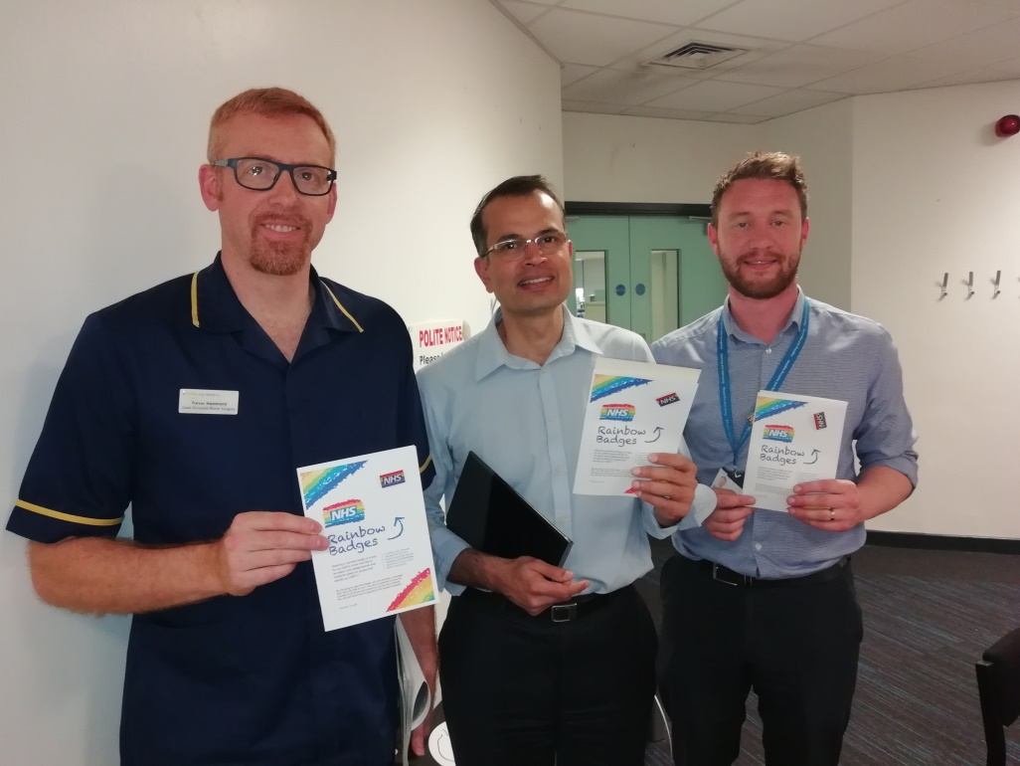

1. **Supporting Vulnerable Adults (Including Learning Disabilities / Mental Health, Children and Young People)**

**Safeguarding Teams**

Safeguarding Adults, Domestic Violence, Learning Disability, Children and Young People, Mental Health and Dementia, work closely together under the wider remit of the Safeguarding Team. The reporting structure for safeguarding is via the Safeguarding Steering Group and then to PSQG. The Trust Safeguarding steering group meets every quarter and includes Divisional membership and on invitation external stakeholders such as the CCGs. For assurance the safeguarding teams produce quarterly reports and yearly annual reports outlining all activity and exception reports where required to ensure risks are highlighted to the Board.

The safeguarding team are available in core hours via a safeguarding duty system; this ensures that all queries are responded to within the working day. Out of hours support is available via the information recorded on the safeguarding intranet site. Work is also underway to develop support processes for senior members of staff out of hours.

**Training**

The safeguarding team facilitates:

* Safeguarding for both children and adults under a combined Think Family remit.
* A Mental Capacity/ Deprivation of Liberty study day is facilitated monthly. This is currently a full day training session facilitated by the Adult Team, Safeguarding Consultant and legal services.
* Safeguarding Adults/children, Learning Disabilities and dementia champion’s networks are in place, with each department nominating Champions for their area. The Champions are supported by the team.
* There is a national PREVENT mandatory e-learning module for all staff to undertake we are able to evidence full compliance with this training and staff are required to update annually via e-learning.
* All the training has been reviewed in line with National developments and also includes themes from safeguarding referrals.
* The safeguarding team facilitate a session on the annual mandatory update; this is updated each year and focuses upon the lessons learnt within hot Trust from a safeguarding perspective each year. We link this also to learning from local and national incidents.
* The Hospital staff continue to receive training on Learning Disabilities via the Induction day (New nurses and Healthcare assistants) and via the Mandatory training programme. This programme has been reinvented with the use of video of the experiences of local patients followed by questions based on observations.

**Learning Disabilities**

The referral processes for patients attending the Trust with a Learning Disability continues to develop, the key to this processes being effective is communication with the patients GP. We are reliant upon them to identify the patients so we can flag their records and develop plans for care to support their transition into the hospital settings.

We are continuing to develop strategies to support staff work with patients with learning disability to support them identify their needs, communicate with them effectively and to identify symptoms of deterioration that may present differently due to the patients underlying presentation.

Referrals continue to come from a variety of sources, however most occur via external agencies. In light of this a Learning Disability Process has been distributed to all wards, a Learning Disability Care Plan has also been created to ensure that any patient admitted receives all the correct and most up to date paperwork. This plan is inclusive of risk assessments, care plans, mental capacity assessments, pain tools, traffic light assessments and discharge planning.

The complexity of cases continues to increase and several referrals have been made for patients without an LD/IDD, but other conditions like ADHD, Asperger’s, Cerebral Palsy and other patients with complex health and social care needs. The age range for referrals is 18years+ however, more and more cases are requiring input at a younger age, with the youngest being 15.

We continue to work with our community colleagues to ensure that the care provided is of an individualised nature and in line with the trusts care values.

**Dementia**

The Trust has responded during the last year to the national requirements for dementia screening and reports this to NHSI on a monthly basis; we have achieved the required target of over 90% for this data consistently over the last year.

The Dementia Nurse Specialist provides training to both staff on the induction, clinical skills and mandatory update sessions. This year the update involved the patients’ voice from the perspective of a carer. This session has been extremely moving and received excellent feedback from the course attendees. Moving into the next year we aim to focus the training on the interface with our mental health colleagues and how we can focus on working cohesively to further improve the patient’s journey.

**Mental Health**

We have over the last year developed more effective processes to ensure that patients who access our services with mental health problems receive timely and safe care. We have forged closer links with the mental health trust and formalised some statutory processes.

We acknowledge that we need to focus during the next year on the mental health of our staff and support managers to help their staff where needed.

# Chaplaincy Services

The Chaplaincy team continues to provide spiritual, religious, pastoral and emotional support for Trust patients, staff, volunteers and families and friends. The Chaplaincy team specialises in providing for specific religious and cultural needs, including holding regular services of prayer and Holy Communion, bedside visiting by the appropriate chaplain or faith representative where possible and responding to all referrals and requests.

Our end of life service has been enhanced by using Nerve Centre. This enables us to visit ward areas and ask staff to offer chaplaincy support to patients and their families. This support is already available with the end of life bundle but the gentle reminder to staff has been welcomed.

Our chaplains offer a non-judgemental, open and empathic listening ear and advocacy support. We are appreciative of diversity and individual need; we always seek to assess need and offer support as appropriate. This involves working with cross-site multi-disciplinary colleagues as well as liaising with chaplaincy colleagues in other Trusts, community faith leaders and other care providers.

The King’s Mill garden and memorial cairn continue to be popular with staff and visitors. People enjoy seeing the flowers and the care that is given to the space. Employees seem to appreciate the quietness of the area when they have breaks and are respectful of the peaceful environment.

The baby loss group spent time clearing the garden area at Mansfield Community Hospital next to the Pilgrim centre and planted some bedding plants which then were watered by the occupational therapy patients as well as chaplaincy staff during visits.

Newark Chapel area has had a screen placed there to develop some privacy for people to use the area more discretely.

We provide inclusive materials and resource for prayer, worship and reflection in our sacred spaces. Our resource boxes are well used in the ward areas.

Each contract funeral and memorial service is always designed to the individual preferences and beliefs of the deceased and their family members as well as staff.

One of our Muslim colleagues said that the chaplaincy service was one of his reasons for deciding to work at Sherwood Forest which is a great tribute to the work done by the chaplaincy team which leads us nicely to our multi-faith provision.

This is a very important aspect of our work. Throughout the year we publicise and recognise the major Christian festivals and also significant religious festivals including Ramadan/Eid and Holocaust Memorial Day. This year we added Diwali to our festivals shared with our Sikh and Hindu staff. The B’hai community come to the Faith Centre four times a year for their significant events.

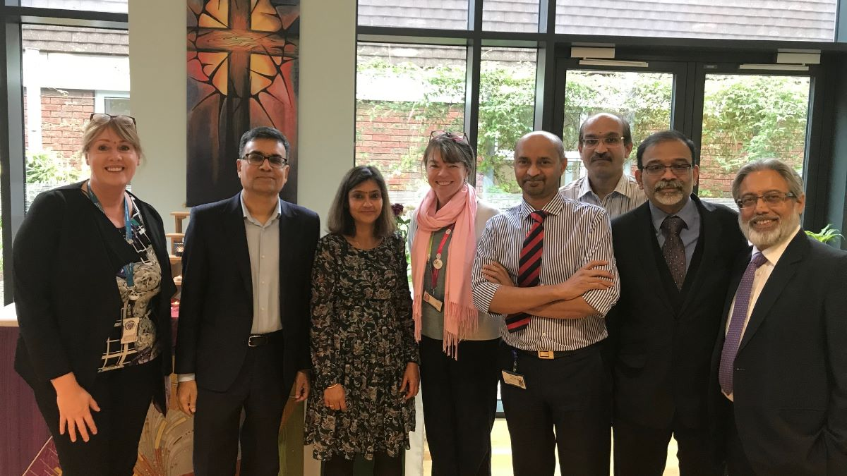

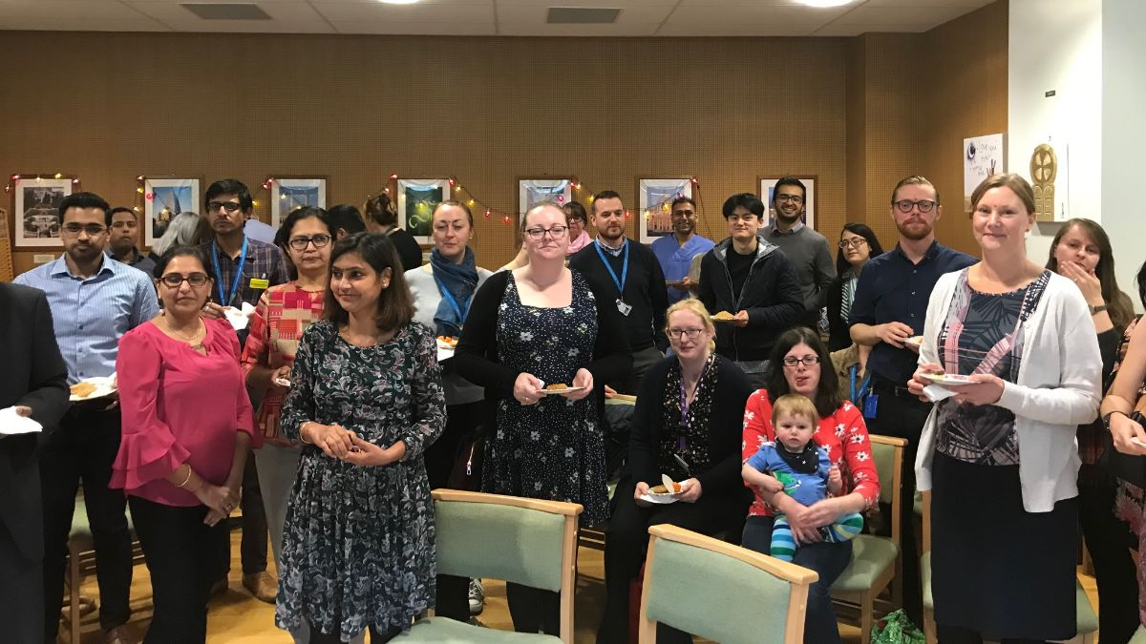

***Chaplaincy Volunteers***

Our volunteer ward visitors continue to support patients and visitors through their weekly visits, greatly enhancing the impact of the chaplaincy team.

**Chaplaincy special events April 2019 to March 2020**

|  |  |
| --- | --- |
| April 19 | Hot cross buns for staff, NWK and KMH |
| May 19 | Memorial service for ICCU x 2 |
| May/Jun 19 | Ramadan Staff support |
| Jun 19 | Eid celebration |
| July 19 | Baby loss memorial service |
| Oct 19 | Licensing service for new Anglican chaplain NWK |
| Nov 19 | Welcome service for 2 free church chaplains KMH |
| Oct 19 | Coffee morning for ICCU survivors |
| Oct 19 | Wave of light in the KTC followed by a walk around the reservoir |
| Nov 19 | Memorial service x2 at KMH; and 1 at NWK |
| Nov 19 | Memorial service for ICCU x2 |
| Nov 19 | Armistice day at KMH/MCH/NWK/AHV |
| Nov 19 | Diwali celebration |
| Dec 19 | Reception of Peace Light from Bethlehem |
| Dec 19 | Memorial services for ICCU and general wards at NWK and KMH |
| Dec 19 | Carol services at KMH NWK |
| Dec 19 | Children’s Memorial service |
| Dec 19 | Christmas Eve Carols |
| Jan 20 | Coffee morning for ICCU survivors |
| Jan 20 | Holocaust Memorial Service |

# Diversity and Inclusivity Initiatives

## 12.1 Diversity Events

To celebrate equality plus raise awareness and promote diversity and inclusivity at the Trust, the following events have taken place during 2019/2020:

* April 2019 - Stress Awareness Month: Throughout the month of April, A Stress Busting stand was show cased across the Trust. The stand comprised of support information for managing stress and mental wellness. During the month, we encouraged colleagues to share their stress-busting tips and creative things they do away from work to relieve stress. Colleagues across the Trust responded well to this and the month concluded with a ‘Stress-Busting Showcase’ in the KTC where we showcased woodwork, knitting, painting and photography to name a few of the wonderful creations that were submitted! The event was attended by Richard Mitchell and Suzanne Banks who chose their favourite stress busting creations and those staff were awarded small prizes which were kindly donated by GMB.

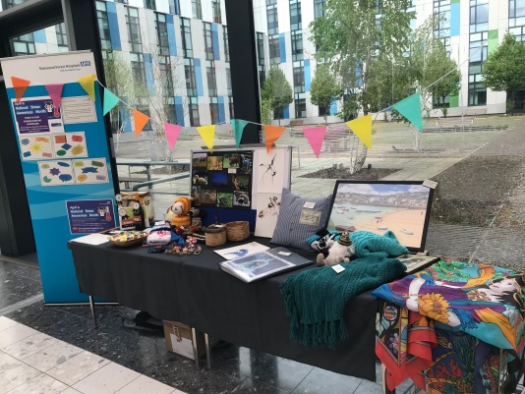

* May 2019 - NHS Equality, Diversity and Human Rights Week and Mental Health Awareness Week – there were information stands at each site to promote awareness of EDI. We also held Time to Change Champion meetings at KMH and Newark hospital to bring the champions together during mental health awareness week.
* May 2019 - International Day Against Homophobia, Transphobia and Biphobia - the HR team manned a stand in the KTC dedicated to the Rainbow Badge initiative.
* July 2019 – PRIDE Event - On 23 July 2019, we held the Trust’s first ever PRIDE event. The event was very well attended and significantly increased the number of staff who signed up to the Rainbow Badge initiative and the LGBT staff network. We were joined by Notts LGBT+ and Notts LBGT+ Service, two local organisations supporting the LGBT+ community. Unison and GMB kindly donated monies for the event which was used to purchase Rainbow wristbands and colourful sweets for the stand!

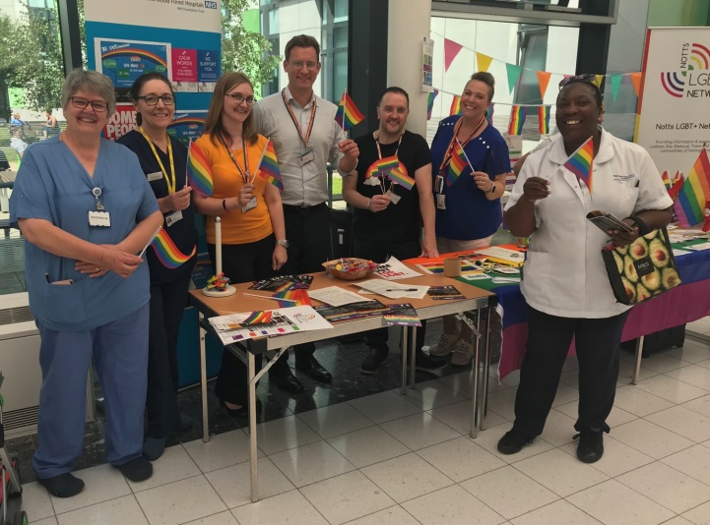

* October 2019 – Black History Month - To launch Black History Month, we set up a display in the KTC which celebrated black history and showcased people that were pioneers for health care and we also showcased some faces from the world of entertainment. Members from the BAME staff network manned the stand and shared their own personal stories. We ensured that the theme of the display was clear by playing music of black origin.

During the month, we invited staff to apply for a place on the Stepping Up programme; a local programme designed to develop leadership skills for BAME staff at Bands 4-6.Our Chief Executive also shared one of our BAME staff member’s moving story in his weekly blog.

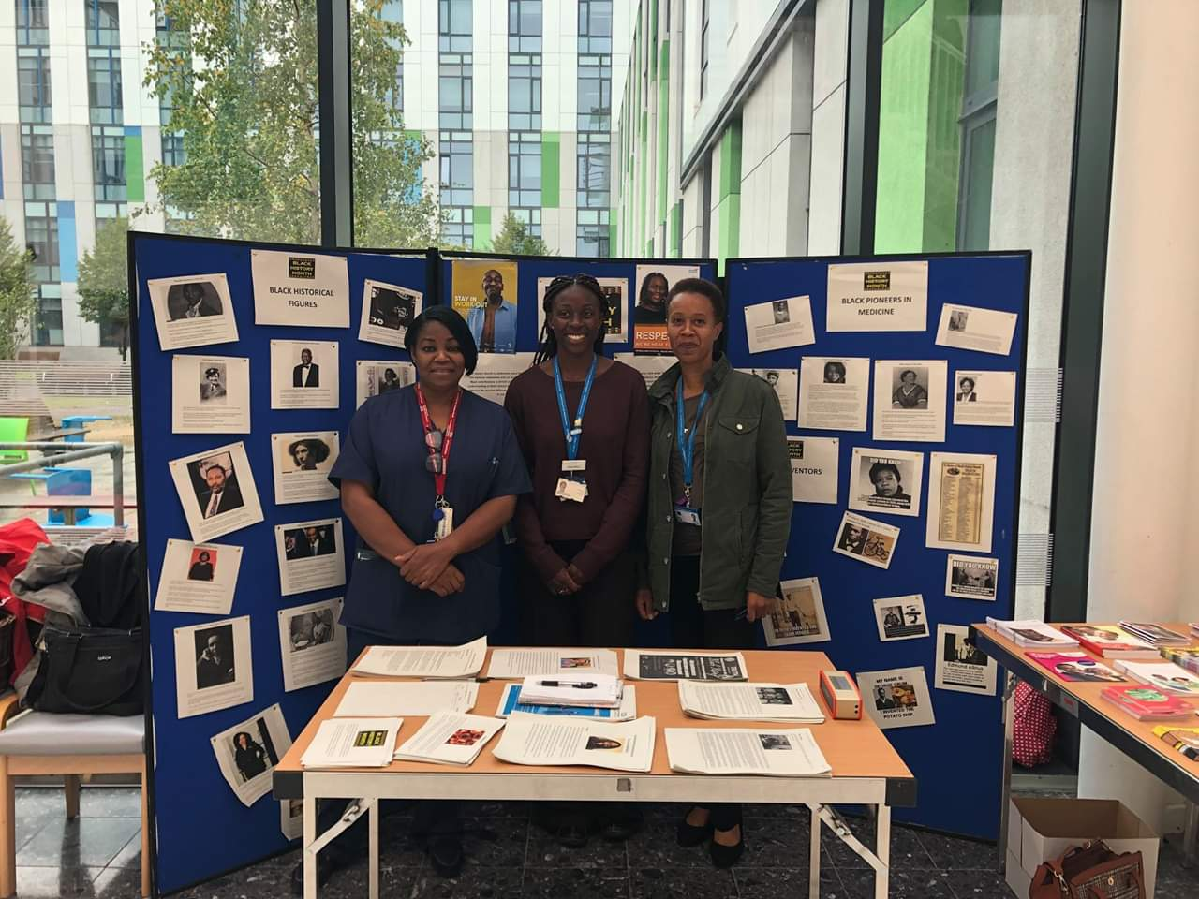

* October 2019 – World Mental Health Day –On 10 October 2019, we held the first of two Mental Wellbeing conferences at Newark. The second conference was held at Kings Mill on 6 November 2019. Both conferences were well attended and covered the following topics;
* Self-help
* Post-natal depression
* Access to Work scheme
* Time to Change, including male depression
* Civility Saves Lives
* Vivup Employee Assistance
* Coping with stress and developing resilience

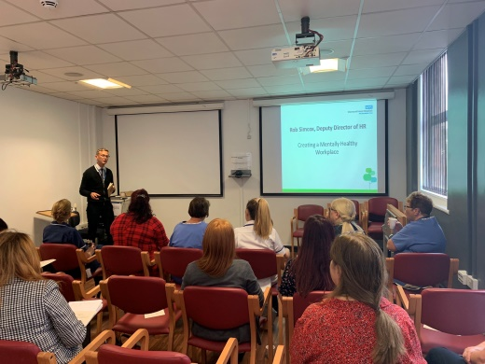

We also held a stand in the KTC dedicated to the provision of mental health support information.

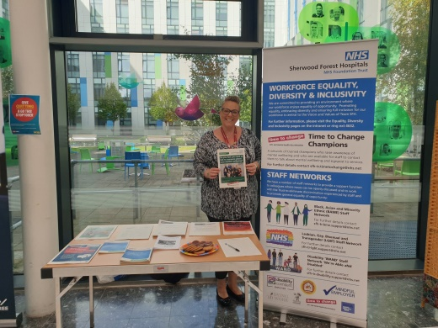

* February 2020 – Time to Talk Day – A series of events to help tackle the stigma around mental health including a tea and talk session was held.

Twitter - In September 2019 we created a dedicated Twitter page: @EqualitySFH enables us to showcase the work we are doing to support the EDI agenda and enables us to connect locally and nationally with likeminded Trusts and organisations.

Important equality and diversity dates have also been incorporated in to the Trust’s Engagement Calendar.

## International Recruitment

The demographic of the whole workforce is 86.85%% White British which is only slightly lower than the population served by Sherwood Forest Hospitals NHS Foundation Trust which is 95% White.  We positively embrace diversity and believe that a diverse workforce, which shares its knowledge and experience, facilitates the provision of high quality patient care. We actively attempt to recruit employees from outside the local area to strengthen diversity.

In summer 2019 a cohort of 20 international nurses started with the Trust. We also continue to provide certificates of sponsorship for professional employees wishing to stay in the UK but move to the local area.

## Translation Services

Throughout 2019/2020 thebigword have continued to provide our interpreting and translation services. The Nottinghamshire Deaf Society also provides a service for sign language. Divisional management secretaries are responsible for liaising with the supplier on a day to day basis and placing our bookings for face to face interpreting services.

We have also recruited a handful of staff volunteer interpreters during the year, but as yet we have not had a need to call on their services as the languages on offer are not often required.

We continue to maintain links with the Interpreting team at Nottingham University Hospitals (NUH) to discuss improvements which can be made to our services. They have also assisted us on a few occasions where we have been unable to obtain an interpreter in certain languages. The Interpreting Manager at NUH is also available as a support mechanism to our volunteer interpreters should this ever be required.

A draft Interpreting Policy has been developed but is yet to go through formal approval processes.

# Safe Places

Kings Mill and Newark Hospitals are designated ‘Safe Places’ via the Patient Experience Offices. This is a Mencap scheme to provide safe places in the community where vulnerable people with learning disabilities can go if they get into trouble or feel unsafe, frightened or bullied. The Patient Experience team liaise with Mencap’s Hate Crime Co-ordinator to report any contacts we receive as a ‘Safe Place’.

# Objectives for 2018/2021

In order for us to continue delivering on the Equality and Diversity agenda for the Trust, the objectives for 2018/2021 that the Equality, Diversity and Inclusivity group will continue to work towards are as follows:

* To continue to ensure the Trust’s services are fully accessible to all patients including making sure information and communication is accessible and specific to patient’s needs in line with the Accessible Information Standards, by engaging with community groups and patients as necessary.
* To increase the number of staff who have self-reported equality data including disability and Sexual Orientation.
* Ensuring we comply with current legislation and public duty including EDS2, WRES, WDES and the gender pay gap to include enhancing the current EDS2 and WRES process by setting up working groups to review and analyse the data and create individual actions plans.
* To increase the knowledge of the Diversity and Inclusivity agenda across the Trust.
* To embed the ‘Time to Change’ mental health employee support across the Trust.